Class I – Maths- 31st July 2019; Wednesday
1. How will the following look , if I turn it UPSIDE DOWN? ( Teachers Please show Objects turned upside down)
i.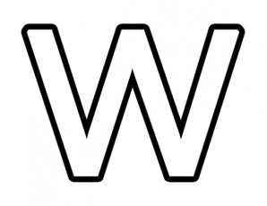______________ ii 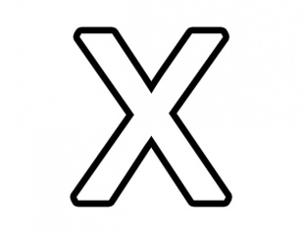_____________

2. What is the shape of a Cell-phone / Mobile phone? ____________.

3. How many CURVES in the following alphabets?
i. 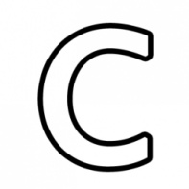______________ ii _____________

4. i. Count how many alphabets make the name of your School:
M I L E S T O N E A C A D E M Y
ii. Underline the vowels and count how many?
****************************************************************
Class II – Maths- 31st July 2019; Wednesday

1. How many words are there in: M U L T IP L I C A T I O N ?

2. How many TENS make a HUNDRED?

3. How many legs will 5 such three-legged stools have?

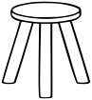 _______

4. I gave away 6 balloons from 9 balloons. How many left?
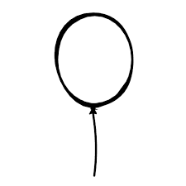 _______
****************************************************************
Class III – Maths- 31st July 2019; Wednesday
1. Find the values of the following:

i. 26-12 + 10 = ______ ii. 6 x 12 = ________

2. There are a dozen mangoes; half a dozen bananas; 2 dozens of apples and 18 plums. How many fruits are there in all?

a. 5 dozens ( ) b. 6 dozens ( ) c. 66 ( ) d. 4¹/₂ dozens ( )

****************************************************************

Class IV– Maths- 31st July 2019; Wednesday
9. i. How many days make a fortnight? __________________
ii. Which among these is a measure of a circle?
a. 90⁰ b. 180⁰ c. 360⁰ d. 120⁰ _____________

10. Look at the numbers 915, 721, 308, 946, 960, 466.
Which among these are divisible by 3?
a. 915, 466 [ ] b. 721, 960 [ ]
c. 915, 960 [ ] d. 308, 721 [ ]

************************************************************

Class V– Maths- 31st July 2019; Wednesday
1. Observe the given figure. How many squares MORE should be shaded so that ³/₄th of the figure is shaded?

a. 18 [ ] b. 12 [ ] c. 24 [ ] d. 6
2. I reach office at 9:55 a.m. I started from home by car at 8:50 a.m. On the way at the railway crossing I had to wait for 17 minutes. If I had not stopped at the railway crossing by what time would I have reached the office?
a. 9:30 a.m [ ] b. 9:17 a.m. [ ] c. 9:38 a.m. [ ] d. 10:05 a.m.
************************************************************************

Class VI– Maths- 31st July 2019; Wednesday
1. Which of the following sets of numbers have the same HCF?
60  650  250 | 230  450 | 120  180  240 | 135  a. Q and R [ ] b. P and R [ ]  c. R and S [ ] d. P and Q [ ]  315  495
P | Q | R | S

2. Kavita and Kiran obtained 75 marks and 25 marks respectively in an examination. Find the ratio of the marks scored by Kavita to their total marks?
a. 4: 3 [ ] b. 3: 1 [ ] c. 1: 3 [ ] d. 3: 4 [ ]
****************************************************************

Class VII– Maths- 31st July 2019; Wednesday
1. In the following figure points M and N divide the line segments PQ and RS respectively into two equal halves.
_{18 cms} _{10 cms} _{14 cms}

P M Q R N S
What is the length of the line segment MN?
a. 28 cms. [ ] b. 26 cms. [ ]
c. 20 cms. [ ] d. 16 cms [ ]

2. A teacher brought some candies to her Class. After giving 3 candies each to students who had completed their assignments; she had 60 candies left with her. How many candies did she bring to the Class?
a. 15 [ ] b. 45 [ ] c. 78 [ ] d. 105 [ ]
*******************************************************************
Class VIII– Maths- 31st July 2019; Wednesday
1. The measure of the angles of triangle PQR are 89⁰, 89⁰ and 2⁰. Which of these is triangle PQR?
a. only isosceles triangle [ ]
b. both acute angled triangle and isosceles triangle [ ]
c. only acute angled triangle [ ]
d. neither acute angled triangle nor isosceles triangle [ ]

2. My father had Rs. 1800 in his wallet. He spent Rs. X on a watch and Rs. 200 to watch a cricket match. Which of these represents the money left in his wallet, in Rupees?
a. 1600- x [ ] b. 2000-x [ ] c. x-1600 [ ] d. x-2000 [ ]
*************************************************************
Class IX – Maths- 31st July 2019; Wednesday
9. What is the formula for finding the volume of a Cylinder and the
volume of a Cone? ___________________________________
10. i. Circumference of a circle = _____________________
ii What would be the difference in the circumference of a circle and a
semi-circle of unit radius? ___________________________________
************************************************************************
Class X – Maths- 31st July 2019; Wednesday
9. What is the average run rate made by a player if he hits 5 sixes, 4 fours in 24 balls?
a. 1.91666 runs / ball [ ] b. 2.5 runs /ball [ ] c. 1.75 per ball [ ] d. 3.99 per ball [ ]
10. The ratio of boys and girls who have taken admission in 2018 in a nursing college is 1: 3
What will be their number of boys : girls if a total of 996 students have taken admission?
a. 747:249 [ ] b. 700 : 296 [ ] c. 296 : 700 [ ] d. 249 : 747 [ ]
*******************************************************************************

Class XI – Maths- 31st July 2019; Wednesday
9. If a student received a score of 85% on a test in which he got six questions wrong, how many questions were on the test?
i. 5 [ ] ii. 40 [ ] iii. 90 [ ] iv. 510 [ ]

10. If the measures of the angles of a triangle can be represented by x +5, 3x-75 and 2x-30, what kind of triangle must it be ?
i. Right [ ] ii. Equilateral [ ] iii. Obtuse[ ] iv. Scalene [ ]
*********************************************************************************
Class XII – Maths- 31st July 2019; Wednesday
1. How many small cubes make a Rubik’s Cube?
i. 36 [ ] ii. 27 [ ] iii. 45 [ ] iv. 18 [ ]
2. In a chessboard there are 64 squares; 32 black and 32 white How many chessmen does each player play with?
i. 32 [ ] ii. 64 [ ] iii. 16 [ ] iv. 8 [ ]
*********************************************************************************

